Mom’s Dilemma
After Dad was released from the Army in Missouri, we came home to the ranch and lived in the ‘Old Ranch house’ and Dad started ranching with Grandpa Lou. Our house was only about 50 yards from Grandpa and Grandma Bitton’s house, which was up the hill. Looking out the south window of our home we looked at the corral and the barn. There were two creeks that merged just east of the house and the Fish Pond was around the corner to the east. The creeks were the Spring creek that flowed over the lava rocks, under the dugway road and cascaded down the lava rocks to the pond. Grandpa Lou had made the pond several years before. He would clean the grate at the dam every morning. The other creek was the north fork of Trout Creek and everything in between and out to the county road was the pasture.
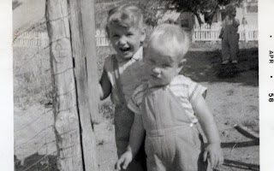
Mom loved to dress me in a dress each day. We had a chicken type wire fence that was around our house and Mom wanted me to stay inside that fence, but I would have nothing of that directive. I believed the whole ranch was my playground. At first I’d open the gate that separated our home from Grandma and Grandpas. So they locked the gate, then I would crawl over the top of the fence. They stopped that by putting wire higher on top. Then I dug underneath the gate, so they put a barrier to that. Then I climbed over the fence in the narrow front yard and walked around in the pasture. I was scared of the cattle guard that separated the pasture from Grandma and Grandpas, but finally mastered that. At a last resort, Mom clothed me in coveralls and said to stay close and away from the men and equipment. It was a great compromise! 